**Project Report on**

**Movie Recommendation**

**Based on Machine Learning using Python**

**Submitted in the fulfilment of our training program**

**By:**

**Harsh Kumar Jha (11900220010) (TEAM LEADER)**

**Rishika Sharma (11900220002)**

**Harsh Sharma (11900220009)**

**Anshika Sahai(11900220036)**

**Trisha Dutta (11900220014)**

**Shubham Divyanshu (11900220008)**

**5th Semester students of**

**Siliguri Institute of Technology**

**Under**

**Maulana Abul Kalam Azad University of Technology**

**Under the supervision of**

**Mr. ARPAN SAMANTA**

# ABSTRACT

**The principal objective of this project is to perform full analysis for the Movie of the employees of the organisation and detect and predict the salaries of the employees using Machine Learning. In this project the concept of Machine Learning using Python has been used to its fullest extent. The data has been collected through a company for the study and implementation of it through Machine Learning. The data collected so far is of experience years and the salary. We know that to bring out the best out of employee an organisation must set some parameters through which a productivity of an employee can be measured. One such metrics is the number of years a person has been in the field. Salary Prediction based on experience using ML: In this project, we have worked on an end-to-end case study to understand the different stages of Model building using the Machine Learning concept. This will deal with "data manipulation" with pandas and Numpy, and "data visualisation" with Matplotlib library with the Salary dataset. After Data manipulation, Data visualisation will be performed using graphs.**

## ACKNOWLEDGEMENT

**It is a great pleasure for us to acknowledge the assistance and participation of a large number of individuals to this attempt. Our project report has been structured under the valued suggestion, support and guidance of Mr. Arpan Samanta. Under his guidance we have accomplished the challenging task in a very short time. Finally, we would express our sincere thankfulness to our family members for inspiring us all throughout and always encouraging us.**

# INTRODUCTION

**Have you ever wondered how YouTube recommends content, or how Facebook recommends you, new friends? Perhaps you’ve noticed similar recommendations with LinkedIn connections, or how Amazon will recommend similar products while you’re browsing. All of these recommendations are made possible by the implementation of recommender systems.**

**Recommender systems encompass a class of techniques and algorithms that can suggest “relevant” items to users. They predict future behavior based on past data through a multitude of techniques including matrix factorization.**

**In this article, I’ll look at why we need recommender systems and the different types of users online. Then, I’ll show you how to build your own movie recommendation system using an open-source dataset.**

**Certificate approval**

**The foregoing project is hereby approved as a creditable study for B.Tech and presented in a manner of satisfactory to warrant its acceptance as a prerequisite to the degree for which it has been submitted. It is understood that by this approval the undersigned do not necessarily endorsed or approved any statement made, opinion express or conclusion therein but approve this project only for the purpose for which it is submitted.**

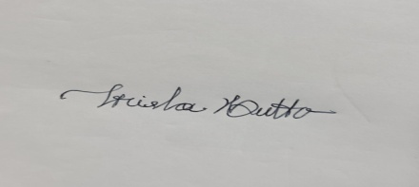 

**TRISHA DUTTA SIGNATURE**

**IT DEPARTMENT ,SIT ARPAN SAMANTA**

**SIKHARTHY INFOTECH PVT.LTD**

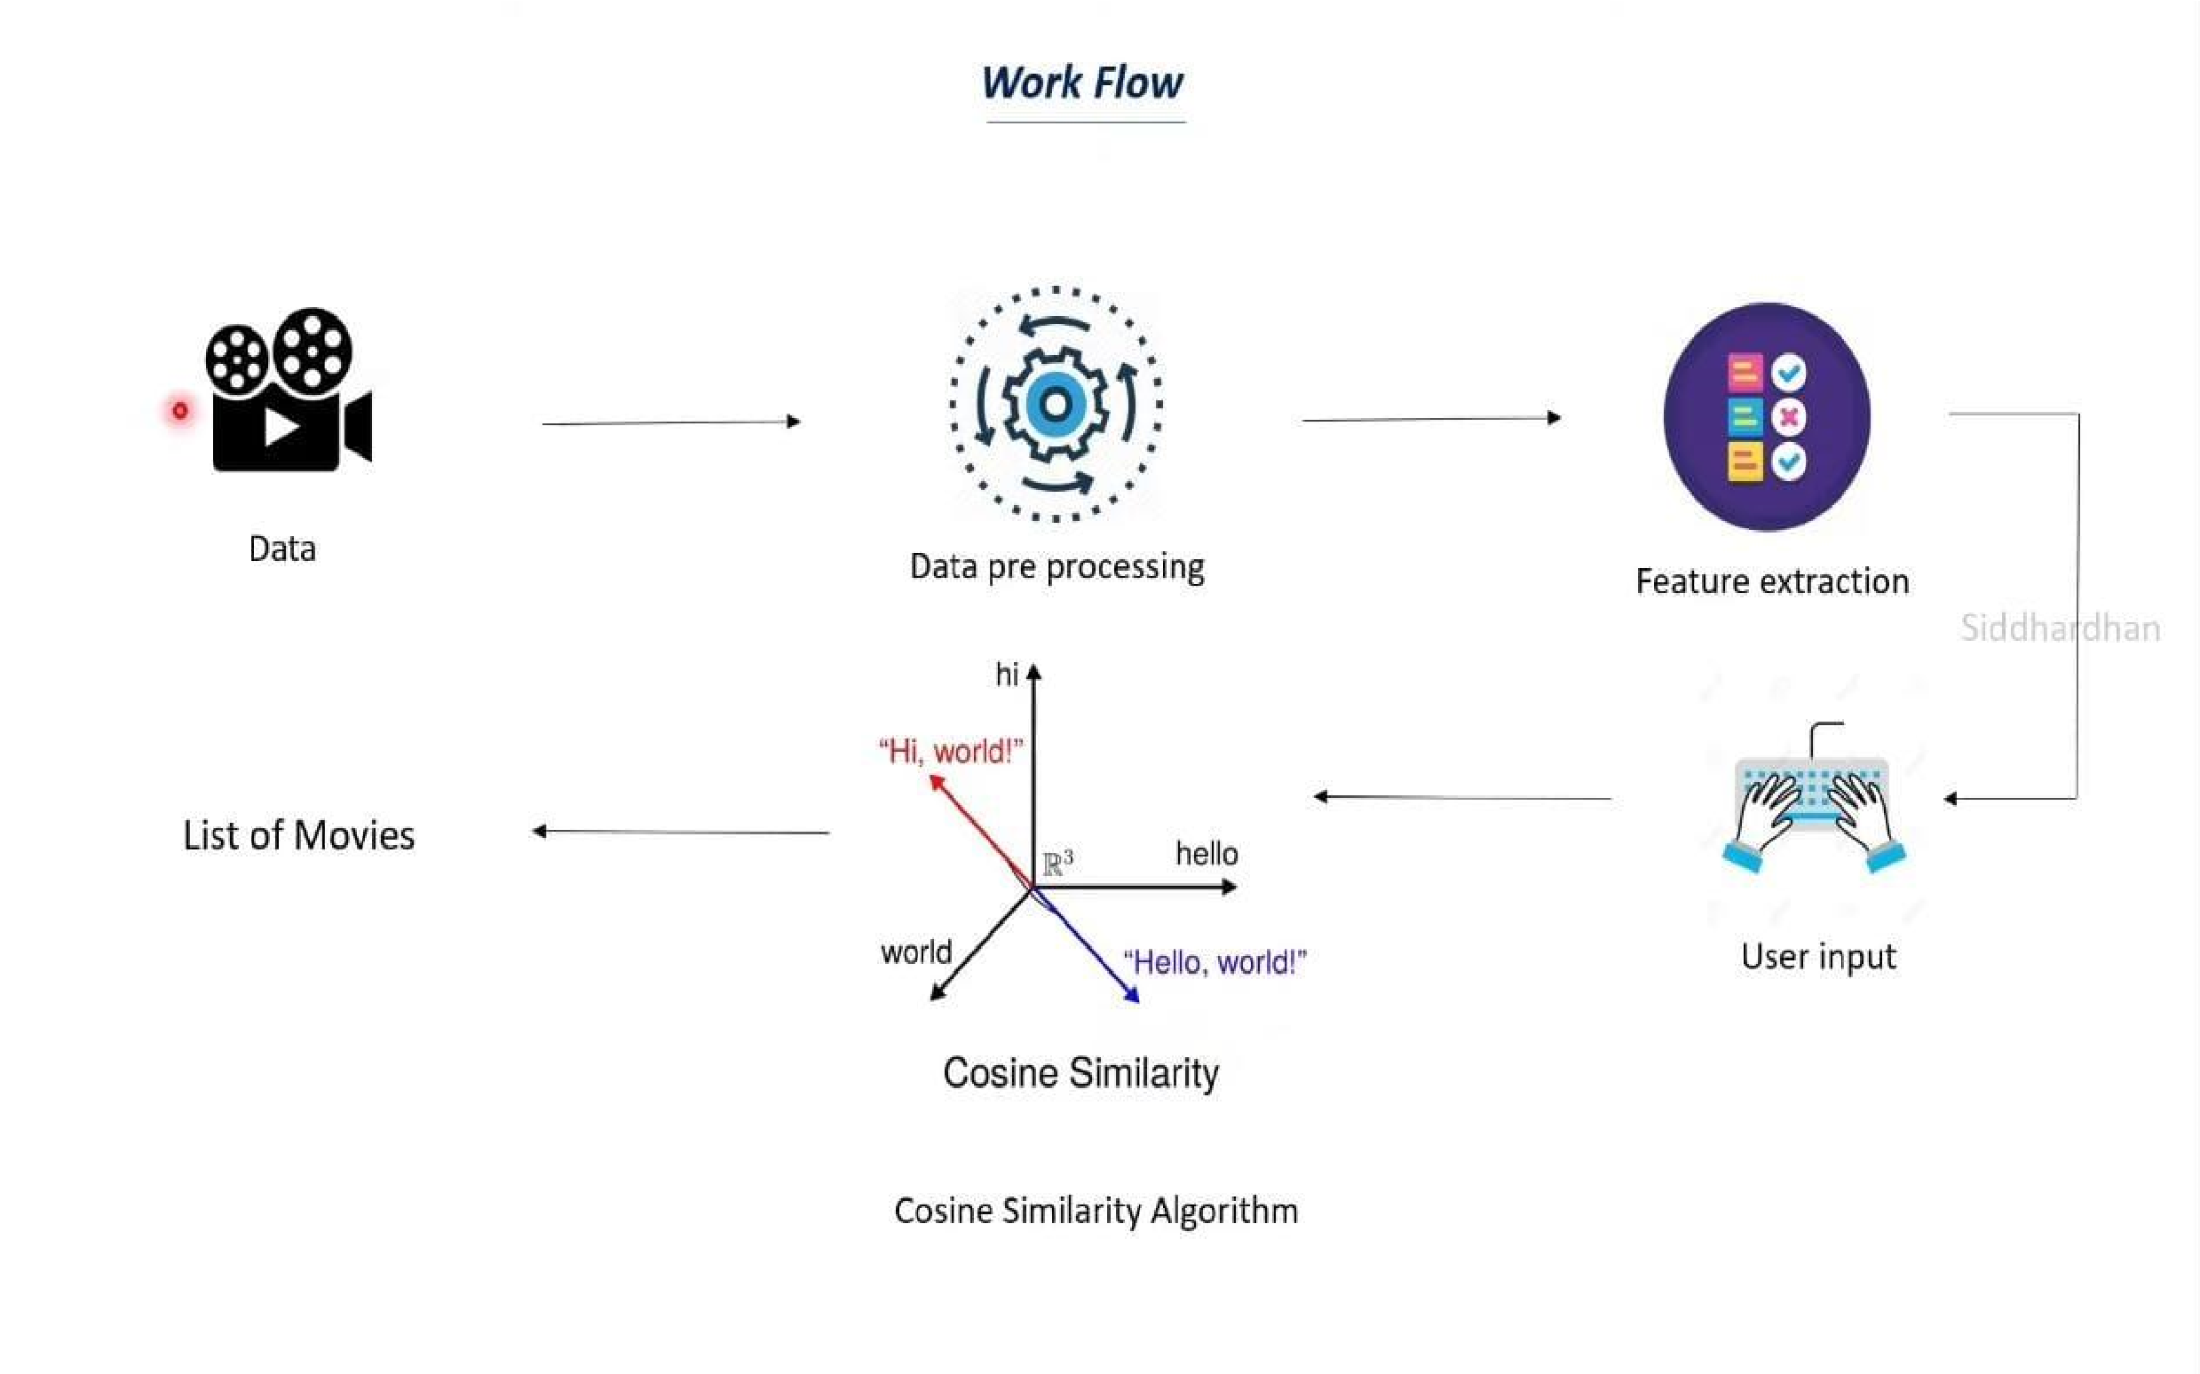

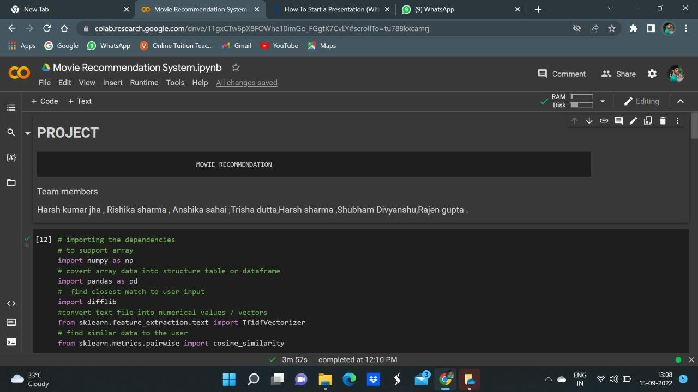**MOVIE RECOMMENDATION USING MACHINE LEARNING:**

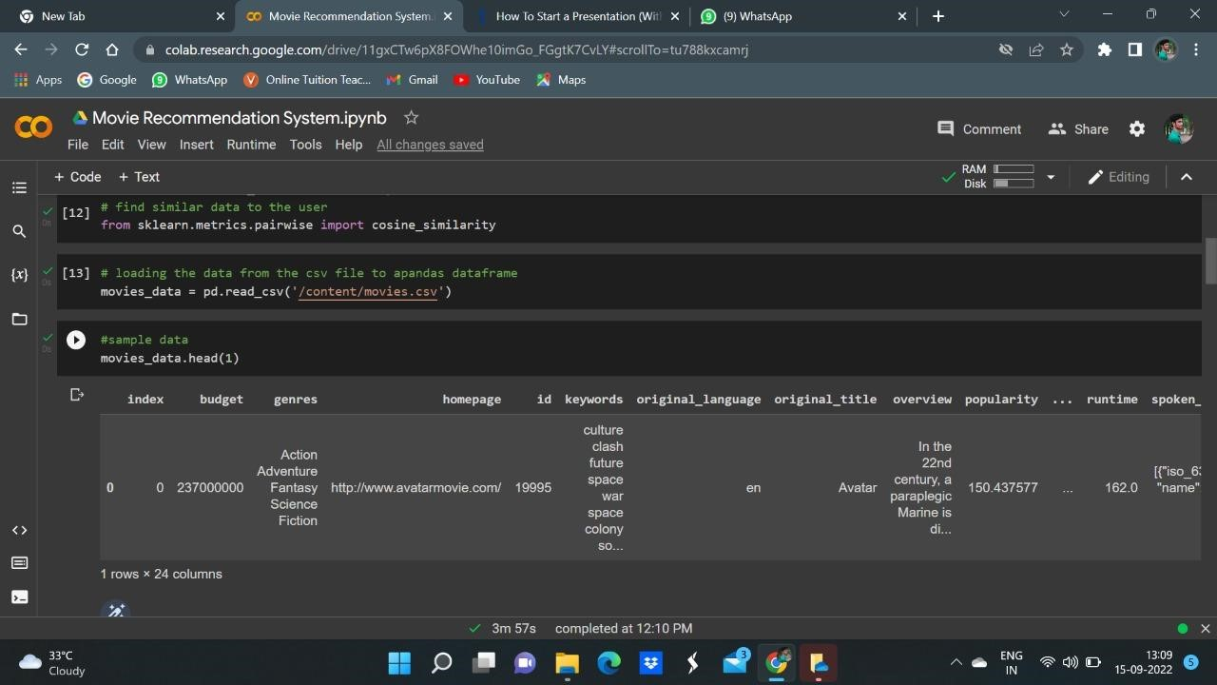

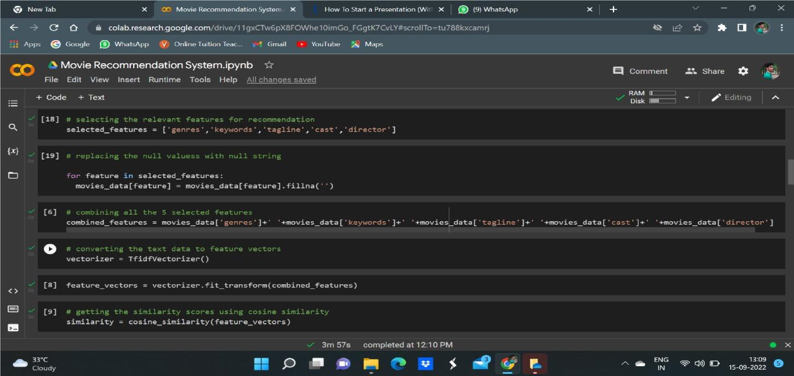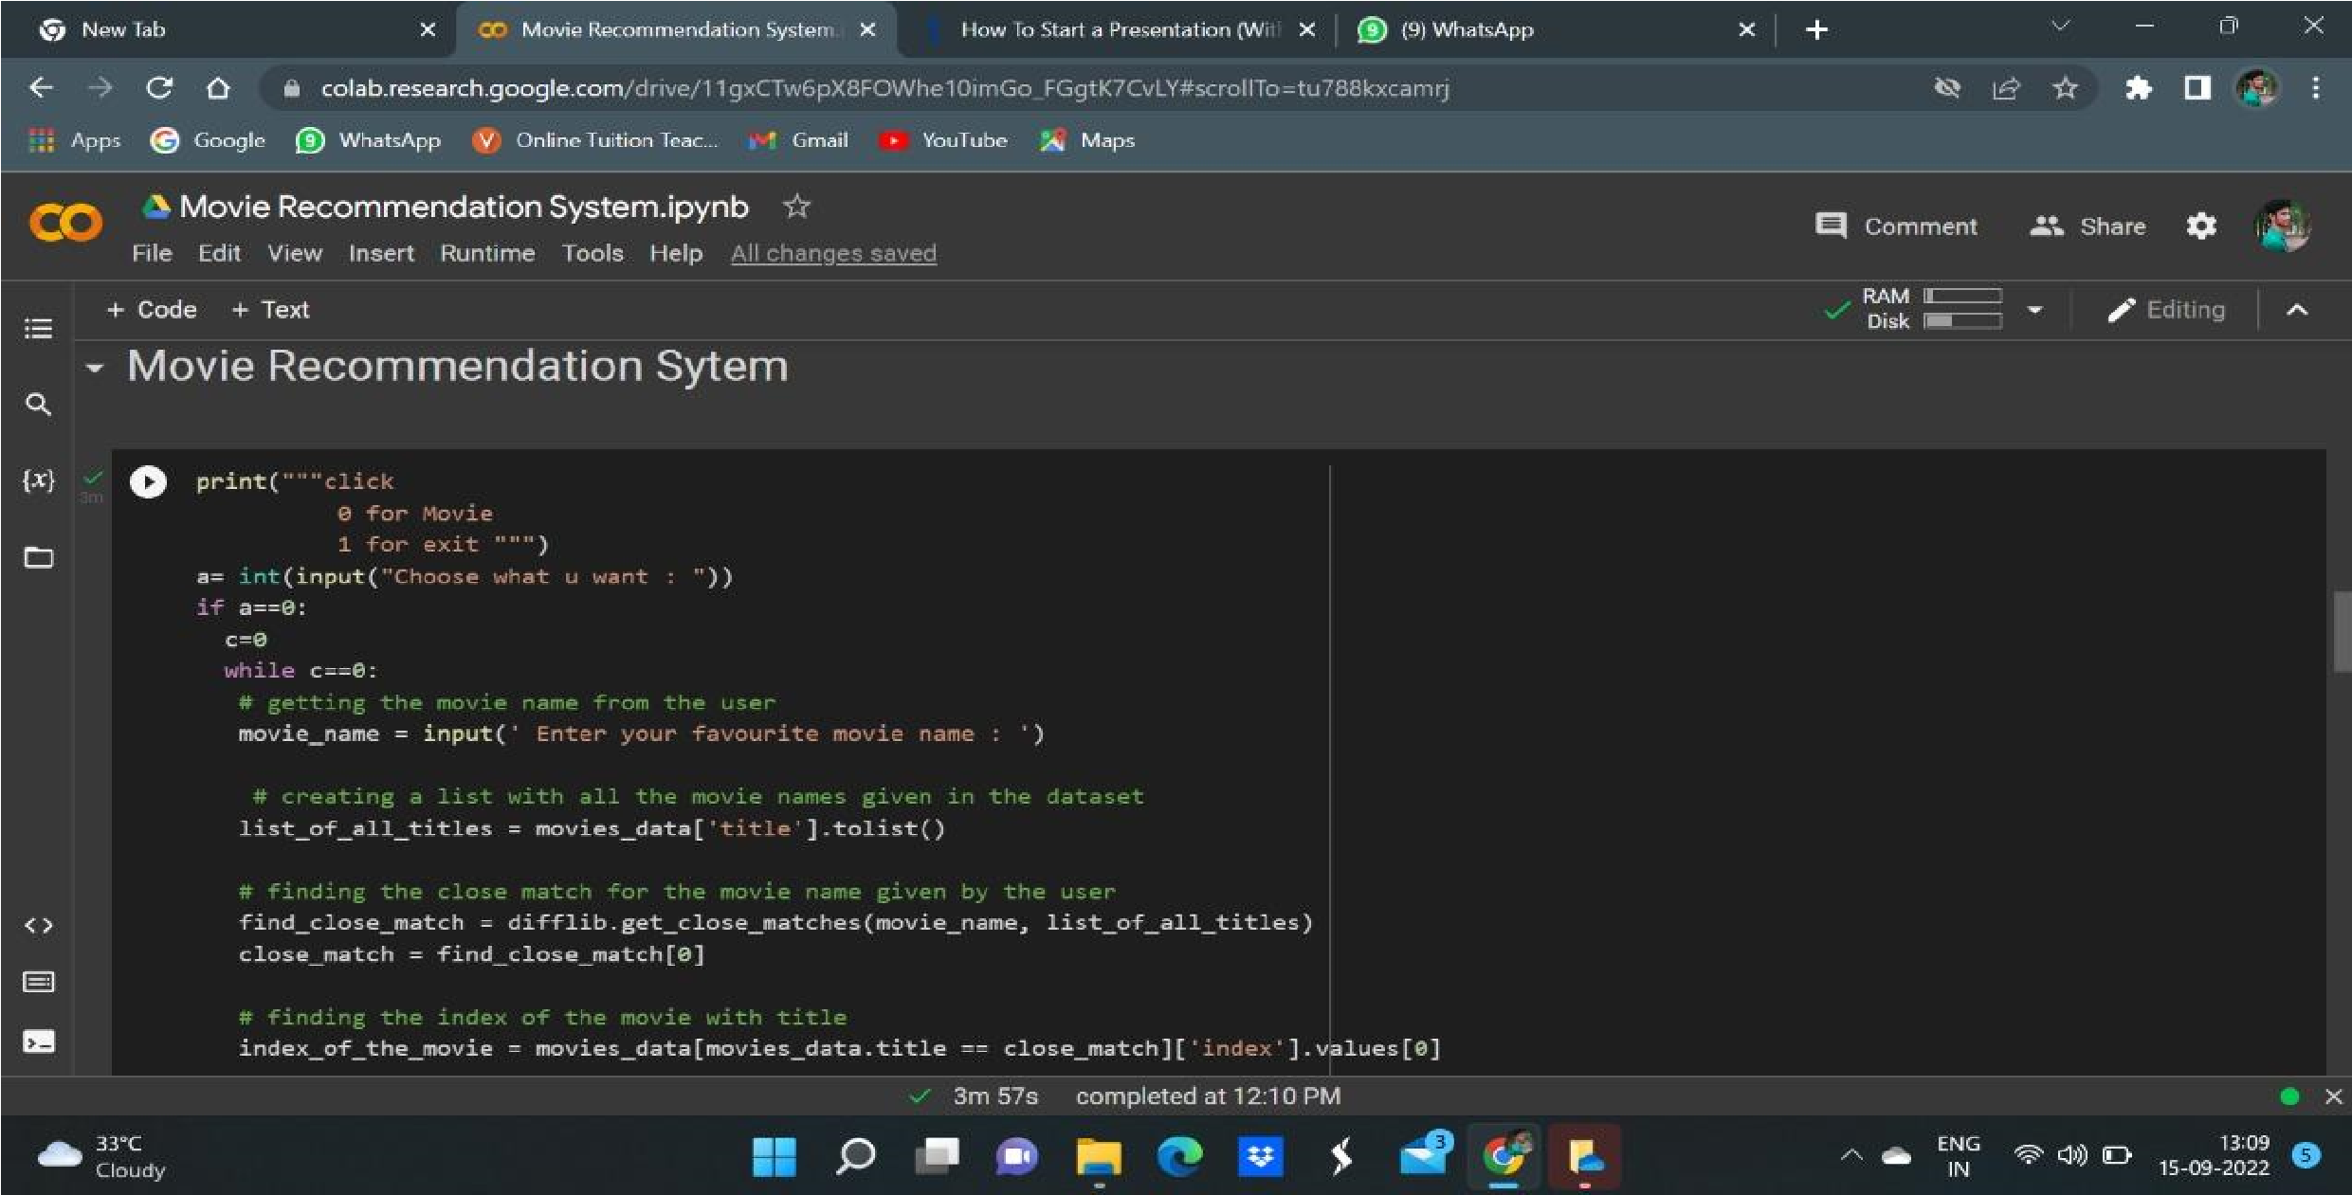

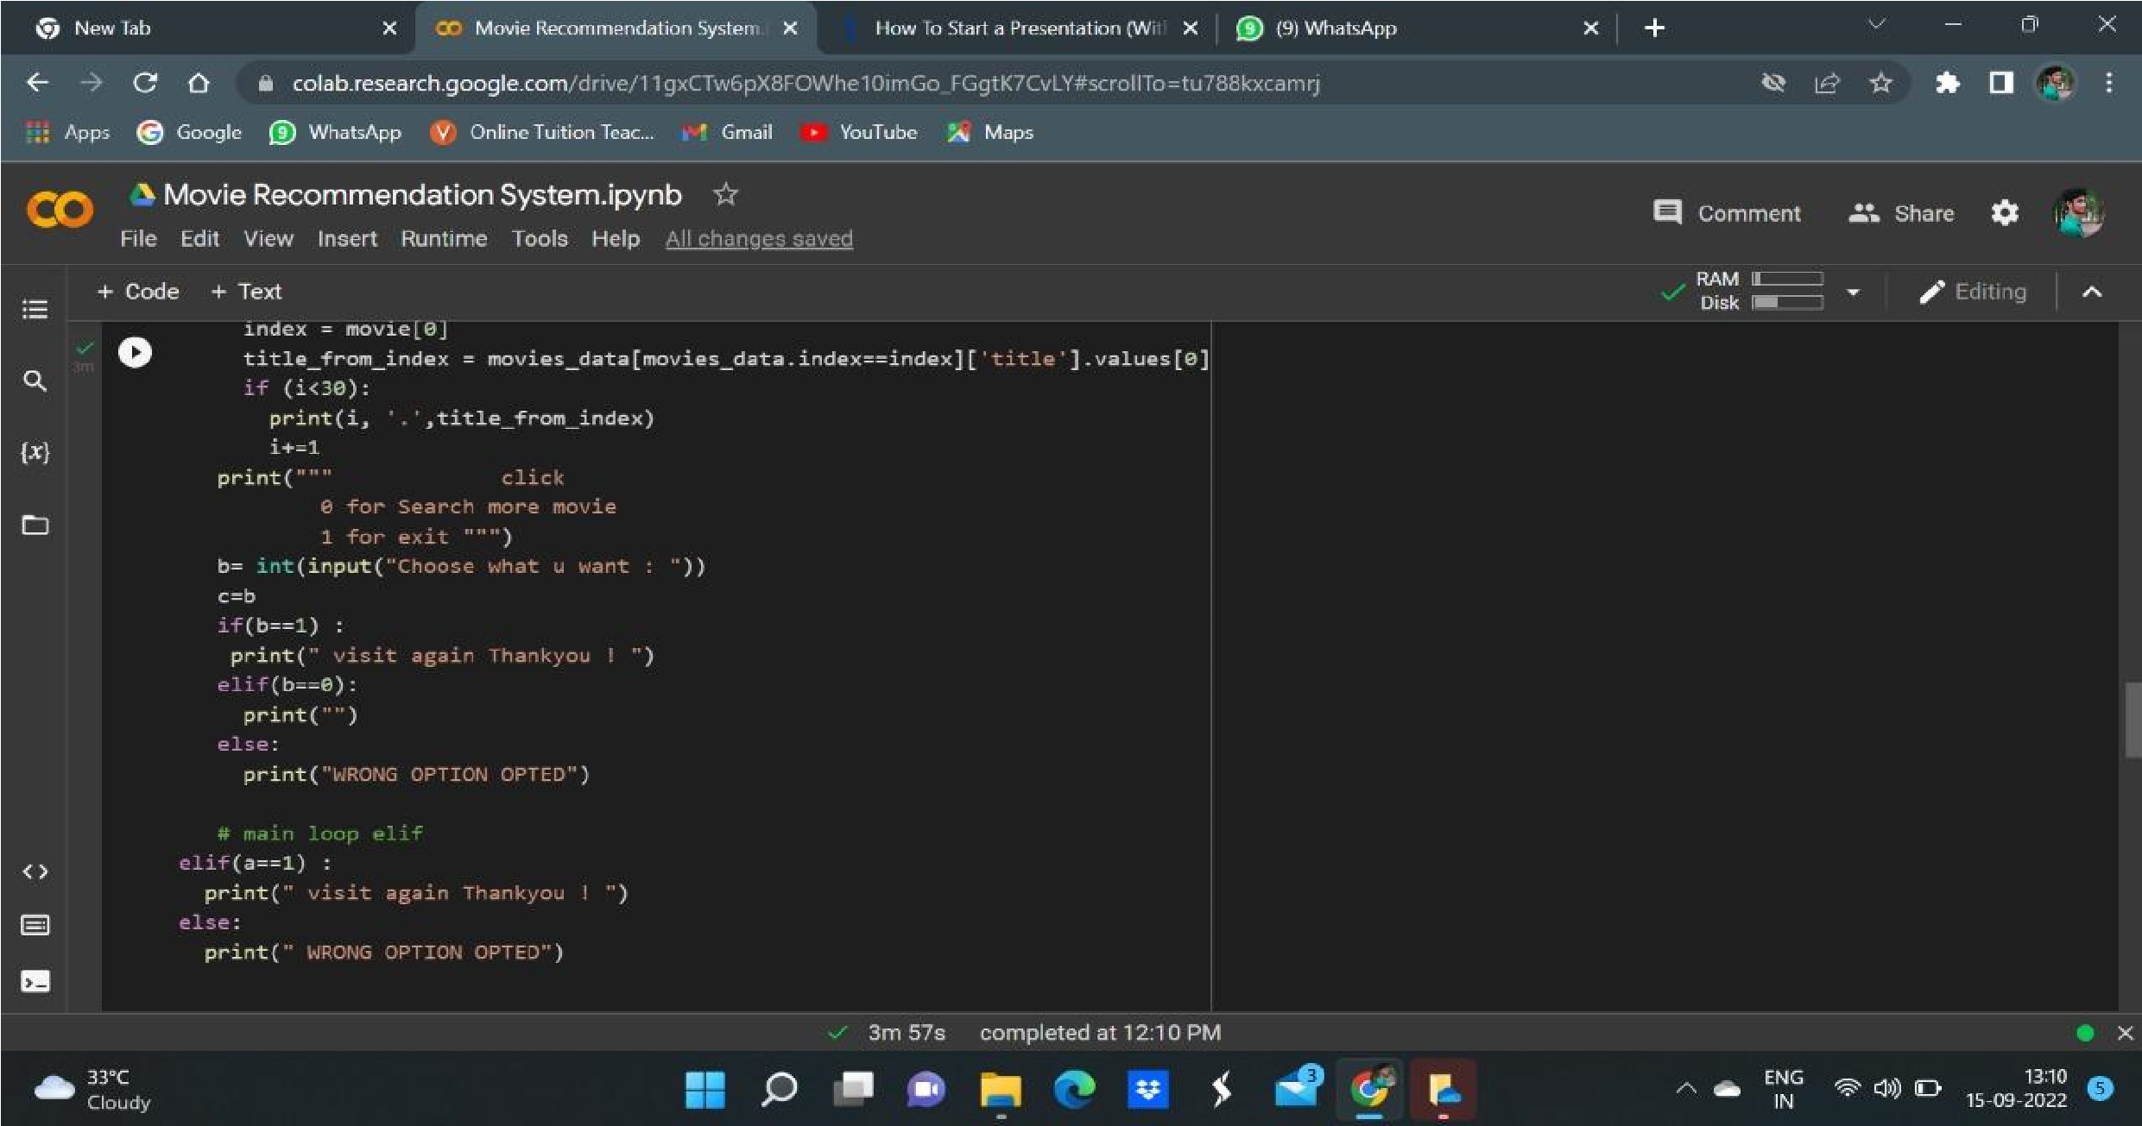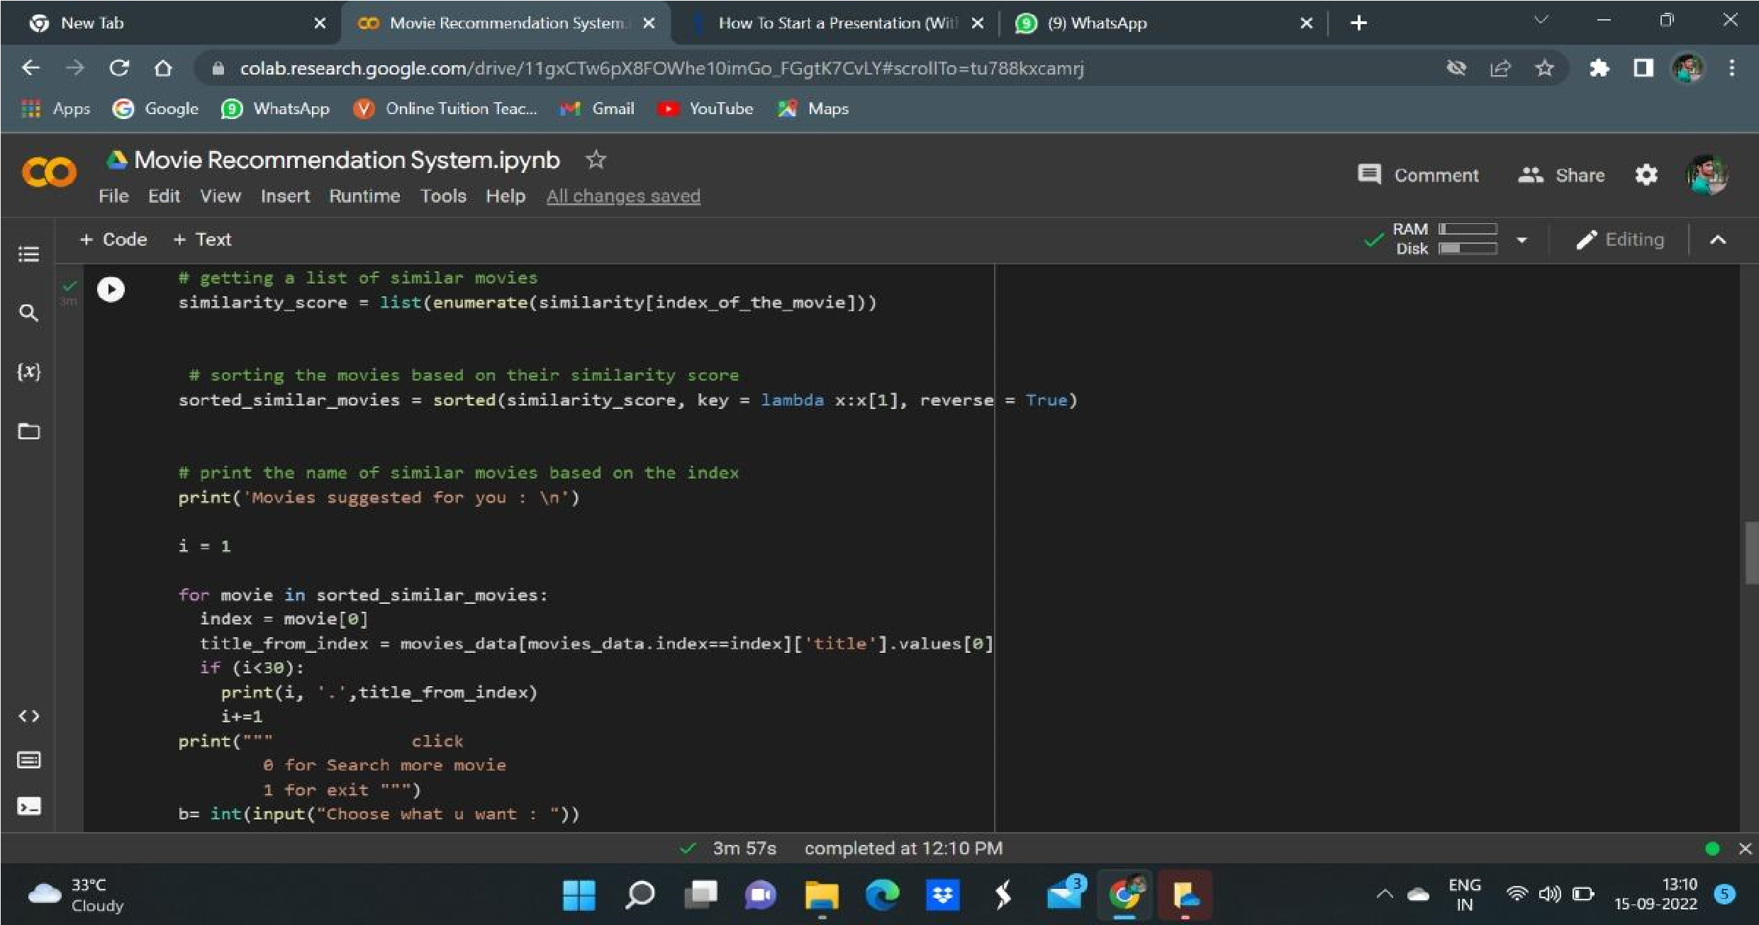

## CONCLUSION

**We have fully completed this project based on Machine Learning using Python to recommend movies to the user by their own experience. We by know that Machine Learning has a huge and vast scope in such genuine problem. It is like that we can improve productivity by getting the knowledge on the basis of the experience a certain employee has over time.**